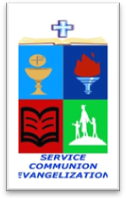
ROMAN CATHOLIC BISHOP OF NOVALICHES
EDUCATIONAL SYSTEM (RCBN-ES, Inc.)
Quirino Highway cor. P. dela Cruz St., Novaliches, Quezon City
Telephone 417-3105

POINTERS TO REVIEW IN SCIENCE 5
School Year 2017 – 2018

THIRD QUARTER

1. Motion
- Describing Motion
- Measuring time and distance using standard units

2. Light and Sound, Heat and Electricity
- Conductors of heat and electricity;
- Effects of light and sound, heat and electricity

3. Electricity and Magnetism
- Circuits
- Electromagnets

